Overview of the Team SNAP Communication App
By: A. Wood, April, 2019

RIDE COORDINATION

Step 1
Download the TEAM SNAP APP and follow the instructions given in the email invitation to join Team Snap.
You can also access Team Snap on your desktop computer.

Step 2
Under the …More Tab, go to My Preferences and turn on the following notifications: Alerts and Schedule Updates; Game/Event Messages; and Team Chat Messages.
Go to your mobile device application settings and turn on Notifications to enable Team Snap.
You will receive notifications whenever there are new messages.

Step 3
Go to the Roster Tab to confirm that your contact info is correct.

Step 4
Go to the Schedule Tab and for a specific ride date, under the heading Details mark your availability as “I’m Going, Maybe or Not Going”. You can add an availability note here as well.
Rides for the entire season are listed.

Step 5
At the top under the Availability Tab you can see the availability of other members for any given ride date.

Step 6
Captains, post your team (captain and stoker) for each ride. To do this, in the Schedule Tab choose a specific date and under the Game Day heading go to Lineup to check off your name and the name of your stoker. This will let the Leaders know the captains and stokers that are expected to ride on a specific date.

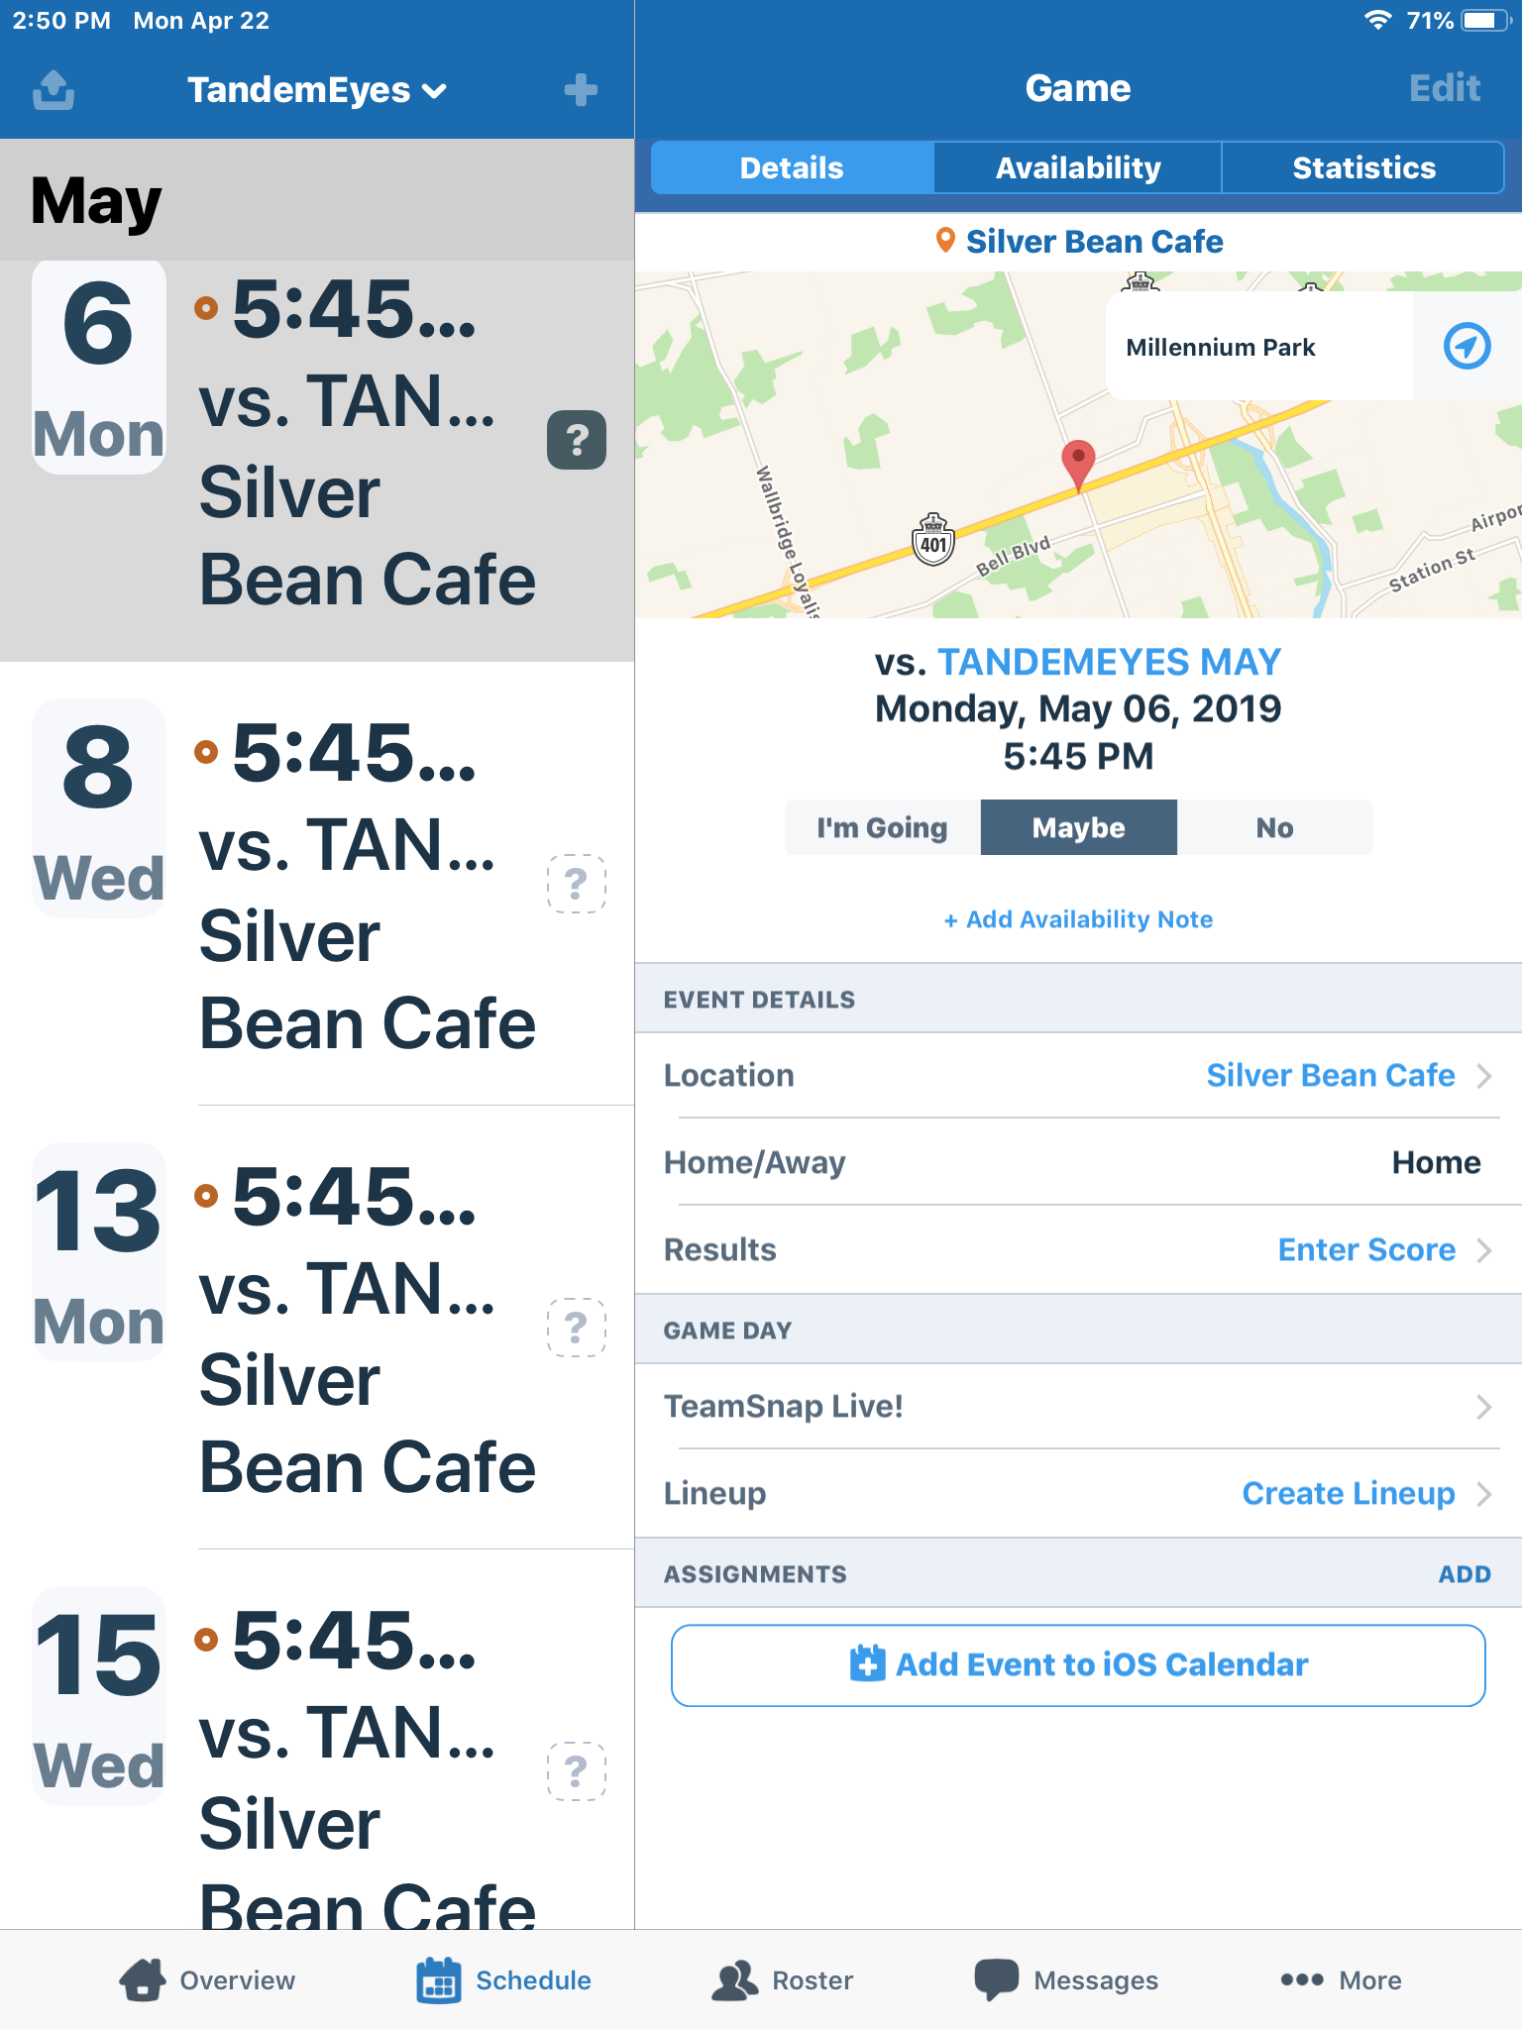

COMMUNICATION

Go to the MessagesTab

Four options are available to members. For each option, load recent messages by refreshing the screen ( pull down the screen).

Option 1. Team Chat
Team Chat is in real time. Messages go out to all members with notifications.
Team Chat can be used to communicate things that require all members to be aware of, e.g., when a replacement captain is needed for a ride.

Option 2. Posts
Are available for all members to see.
Can also broadcast the post by email.
Respond to a post using the arrow in the upper right of the screen.
Used primarily by TandemEyes Administrators to post events or messages for everyone to read.

Option 3. Emails
Send emails to specific members.
You can ONLY respond to Team Snap emails through your email address, not through Team Snap.

Option 4. Alerts
Are in real time.
Members receive notifications.
Often used to cancel rides and for members to communicate with one another.
To respond to an Alert, you need to hit the + sign to start a new Alert to that member.

HELP AND SUPPORT

Go to the …More Tab and then to Help and Support.
If you can’t find the answer to your question(s), please phone:
Anne Wood
705-741-3406
705-931-3407 (cell)

